**Foundations of Deep Learning – Homework Assignment #3**Adi Album & Tomer Epshtein

**Part 3: (4)**

Question:

On a scalar regression dataset of your choice, train a depth $N$ linear neural network (with hidden widths no smaller that the minimum between input dimension and output dimension) by minimizing $l_{2}$ loss via (full batch) gradient descent with small learning rate and initialization close to zero. Compare the trajectory taken by the end-to-end matrix to that obtained by directly applying the (discrete version of the) end-to-end dynamics to a linear model:

$$W_{t+1}←W_{t}-η\sum_{j=1}^{N}{{\left[W_{t}W_{t}^{T}\right]}^{\frac{j-1}{N}}∇l\left(W_{t}\right){\left[W_{t}^{T}W_{t}\right]}^{\frac{N-j}{N}}} ; t=1,2,3,…$$

Where $η$ is the learning rate used for gradient descent over the linear neural network. Repeat the experiment with depths $N=2$ and $3$

Solution:

The training procedure can be viewed in the following plots:

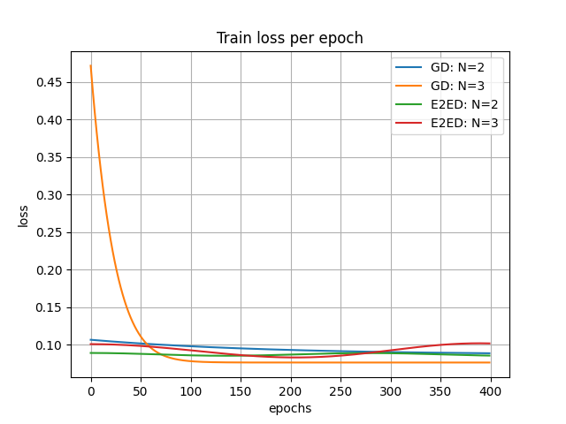

Convergence of all four models: GD with $N=2,3$ and E2ED (End-to-end dynamics) with $N=2,3$ is achieved.

Additionally, because our network is a Linear Neural Network with input dimension $1$ and output dimension $1$, the end-to-end matrix is a $1×1$ matrix. I.e. a single real value. We can see convergence to global minimum, with different learning rates, in the following graph, where all four models converge to and end-to-end matrix $≈{\left(1.7\right)}_{1×1}$

